Nolan Arendt
Binosh Padman
IST 707 Applied Machine Learning
Course Project Instruction
1. Project Format
The objective of the project is to use the main skills taught in this class to solve a real data mining problem. Students can choose to work individually or pair up with another student.
2. Choose data mining problem and data set
For this project, you must choose your own dataset. It can be one that you created yourself or found from other resources, such as the Kaggle competitions and the UCI repository (http://archive.ics.uci.edu/ml/).
Some rules/tips about choosing data sets:
a. Do not choose the data sets that we have analyzed in class, such as the Titanic data, the zoo data, etc.
b. It should not be a small or made-up dataset. For this semester, “small” is defined as fewer than 50 examples in the dataset.
c. Choose a data set that does not require excessive data preprocessing.
3. Experiment design
Define a problem on the dataset and describe it in terms of its real-world organizational or business application. The complexity level of the problem should be comparable to HW4 or HW7 assignment.
The problem may use one or more of the types of data mining algorithms that we have studied this semester: Classification, Clustering and Association Rules, in an investigation of the solution to the problem.
This investigation must include some aspects of experimental comparison: depending on the problem, you may choose to experiment with different types of algorithms, e.g. different types of classifiers, and some experiments with tuning parameters of the algorithms. Alternatively, if your problem is suitable, you may use more than one of the algorithms (Clustering + Classification, e.g.). If there are a larger number of attributes, you can try some type of feature selection to reduce the number of attributes. You may use summary statistics and visualization techniques to help you explain your findings.
No need to use all of them. Some explanation is needed to justify your choice of algorithms.
4. Project idea proposal
• Submit a one-pager to describe the data mining problem, the data set, and your initial strategies for data analysis 48 hours prior to the Week 7 Live Session ("Naïve Bayes").
• You are encouraged to read each other’s proposal to learn from each other.
• It’s OK to choose a data set that another student also chooses to use, as long as your work is independent from each other.
• Your proposal will be commented but not graded. Comments will focus on whether the problem modeling is appropriate, whether the project complexity is appropriate (if not, suggestion for adjustment), and whether the initial data analysis strategy is reasonable.
5. Project progress report
Each student should submit a project progress report 48 hours prior to the Week 9 Live Session. You are expected to have finished all experiments and a draft project report. This round of feedback is expected to help you fix major problems in your research design and result analysis. Your report will be commented but not graded.
6. Final project report
To complete this project, write a final report that conforms to general academic paper format. Make sure to cite relevant work appropriately. Your report should be within 8 pages, 1 inch margin on all sides, and at least 12 point Arial or Times New Roman. Submit your final report 48 hours after the Week 10 Live Session

Introduction
In the wake of the global pandemic caused by the coronavirus infection, understanding the various symptoms, pre-existing conditions, and behavioral factors associated with COVID-19 has come paramount. The dataset under study captures comprehensive information related to these factors, encompassing a range of symptoms such as fever, dry cough, and breathing problems, as well as behavioral aspects like travel history and exposure to public places. With a sample size of 5,434 individuals, this dataset provides a rich source of information that can be leveraged to discern patterns and predict the likelihood of a positive or negative COVID-19 outcome.
Creating a predictive model using classification and clustering techniques based on this dataset can serve multiple purposes. First, it can aid healthcare providers in early detection and triaging of potential COVID-19 cases, especially in scenarios where testing resources are limited. Second, understanding which symptoms or behaviors are more strongly correlated with positive outcomes can guide public health initiatives, leading to more targeted awareness campaigns. By harnessing the power of data analytics and machine learning, we aspire to contribute a valuable tool in the ongoing fight against this pandemic.
Literature Review
Several studies have applied machine learning to COVID-19 datasets for predicting severity and other valuable insights. The article titled “COVID-19 diagnosis prediction in emergency care patients: a machine learning approach” by André Filipe de Moraes Batista, et all focused on predicting COVID-19 diagnoses in emergency care patients, with Support Vector Machines performing well.
The article titled “Identifying Predictors of Psychological Distress During COVID-19: A Machine Learning Approach” by Tracy A. Prout1, et all explored the impact of the pandemic on mental health, finding that age, gender, and emotional coping strategies played significant roles.
The article titled “Machine Learning-Based Model to Predict the Disease Severity and Outcome in COVID-19 Patients“ by Sumayh S. Aljameel, et al. aimed to predict disease severity in COVID-19 patients, emphasizing the potential of machine learning in early intervention.
The article titled “The COVID-19 pandemic: prediction study based on machine learning models” by Zohair Malki, et al. applied decision tree algorithms and linear regression to real-time data from sources like Johns Hopkins University and the World Health Organization to predict COVID-19 spread in multiple countries.
The article titled “COVID-19 Future Forecasting Using Supervised Machine Learning Models” by Rustam, et al. explored the application of supervised machine learning models in forecasting the future impact of COVID-19. They examined various models, including linear regression, LASSO, support vector machine, and exponential smoothing, to predict new cases, deaths, and recoveries in the next 10 days. The research showcased model performance and discussed the extension of forecasting scope over time and the use of prediction intervals to quantify uncertainty, with linear regression being a preferred model.
Data Description
The dataset under examination serves as a comprehensive repository capturing a wide array of factors associated with COVID-19. Comprising 5,434 individual records, the data delves into both the symptomatic manifestations and potential behavioral risk factors of the virus. On the symptomatic front, the dataset encapsulates common symptoms like fever, dry cough, and sore throat, while also shedding light on more symptomatic conditions such as asthma, chronic lung disease, and heart disease. These indicators provide a holistic view of the individual’s health status and potential COVID-19 related symptoms.
Transitioning to behavioral and exposure risks, the dataset details aspects such as travel history, particularly abroad travel, and direct contact with a confirmed COVID-19 patient. Furthermore, it provides insights into potentially high-risk behaviors, including attendance at large gatherings and visits to public exposed places. In addition, factors such as family members working in public exposed areas offer a nuanced understanding of indirect exposure risks. Notably, the dataset also captures preventative measures, albeit with surprising revelations, like the apparent absence of mask-wearing and sanitization practices among the participants. The culmination of these data points is the final column, indicating whether the individual tested positive or negative for COVID-19, serving as a pivotal outcome variable for this study.
Preprocessing
The initial phase of our data preprocessing involves converting categorical variables into a format suitable for machine learning algorithms. One of the most pivotal columns “COVID-19”, which represents our target variable, contains textual data indicating ‘Yes’ or ‘No’ responses. To streamline our modeling process, this column will be transformed into nominal values, with ‘Yes’ mapped to 1 (indicating a positive COVID-19 test) and ‘No’ mapped to 0 (indicating a negative COVID-19 test).
Furthermore, any missing values within the dataset will be identified and addressed using appropriate imputation strategies or removal from the dataset completely. Given the nature of our dataset, it’s imperative to ensure that no data point is left ambiguous, as it could impact the accuracy and reliability of our predictive models. A critical observation made earlier was the imbalanced distribution of the “COVID-19” column. Such an imbalance can skew model performance, making it biased towards the majority class. To rectify this, we will employ techniques such as undersampling the majority class. Finally, the dataset will be normalized to ensure that all variables are on a comparable scale, optimizing the performance of certain algorithms that are sensitive to feature scales.
Exploratory Data Analysis (EDA)
The exploratory data analysis phase of the project provided pivotal insights into the dataset’s structure and relationships among its variables. A core component of this EDA was the correlation analysis, which aimed to discern the linear relationship between the individual features and the “COVID-19” outcome. Symptoms such as sore throat, dry cough, and breathing problems emerged as strongly correlated with a positive COVID-19 diagnosis. Simultaneously, behavioral aspects like abroad travel and attending large gatherings also displayed significant positive correlations. These findings set the stage for feature selection and model building, as understanding these relationships is crucial for predictive accuracy.
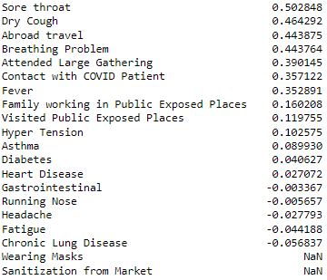
Figure 1: Ranked Correlation Coefficients between Features and the COVID-19 Outcome
Moreover, the EDA brough to light certain columns with a lack of variation in responses. Specifically, the “Wearing Masks” and “Sanitization from Market” columns had unanimous “No” responses from all participants. This uniformity potentially points to data collection challenges or might represent behavioral tendencies during the pandemic’s early stages where preventative measures might not have been as widespread. Such columns with no variation can be deemed redundant for modeling purposes, as they do not contribute any discriminatory power to distinguish between positive and negative outcomes.
Logistic Regression Classification
The Logistic Regression classifier, tailored with specific hyperparameters, was trained to predict COVID-19 outcomes based on various symptoms and behavioral factors. The model was particularly adjusted to handle the class imbalance inherent in the dataset by setting the ‘class_weight’ parameter to ‘balanced’. This configuration ensured that the classifier penalized mistakes in the minority class (negative COVID-19 cases) more than the majority class (positive COVID-19 cases) during its training process.
Upon evaluation, the classifier exhibited an accuracy of approximately 83.63% on the test data. The confusion matrix provided deeper insights into the model’s performance nuances. With a high recall for positive cases, the model demonstrated an excellent ability to identify individuals who tested positive for COVID-19. However, this came at the expense of the recall for negative cases, which was considerably lower. This trade-off suggests that while the model is highly sensitive to detecting positive cases, it tends to misclassify a significant portion of actual negative cases as positive. This behavior underscores the challenges of working with imbalanced datasets and the importance of carefully selecting performance metrics that resonate with the problem’s specific objectives.
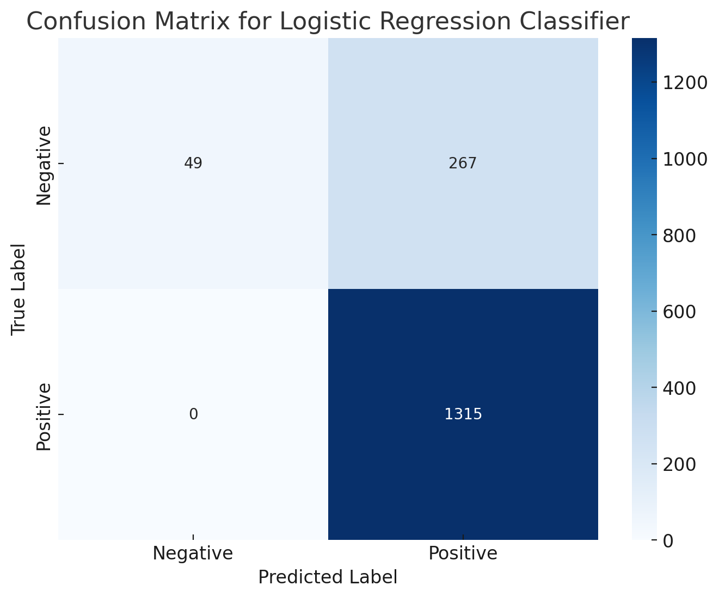
Figure 2: Confusion Matrix for the Logistic Regression Classifier

Random Forest Classification
The Random Forest classifier was meticulously calibrated with a designated set of hyperparameters to predict COVID-19 outcomes, drawing upon a diverse array of symptoms and behavioral variables. A crucial aspect of the model’s configuration was its explicit consideration of the dataset’s class imbalance. By employing the ‘class_weight’ = ‘balanced’ parameter, the classifier was designed to adjust the weights of classes inversely proportional to their frequencies. The adjustment ensures that during the training phase, errors in predicting the minority class are penalized more severely than those in the majority class.
Upon subsequent evaluation on the test dataset, the classifier achieved an accuracy of approximately 80.63%. A deep dive into the confusion matrix elucidated the nuances of the model’s performance. While it demonstrated an aptitude for identifying positive COVID-19 cases, the model’s sensitivity came at the cost of its ability to accurately predict negative cases. This bias towards positive predictions, despite the balanced class weighting, highlights the intricate challenges inherent in addressing class imbalances. It underscores the importance of a multifaceted approach, encompassing not just balanced class weighting but potentially other techniques like resampling, when working with skewed datasets.
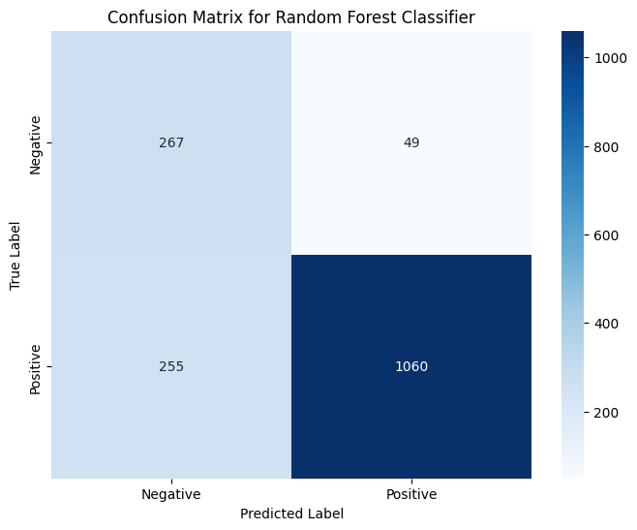
Figure 3: Confusion Matrix for the Random Forest Classifier
Decision Tree Classification
The Decision Tree classifier was constructed employing a distinct set of hyperparameters to predict COVID-19 outcomes based on a combination of symptoms and behavioral indicators. By integrating a ‘max_depth’ of 3, the tree’s complexity was purposefully restrained, ensuring it remains interpretable and avoids potential overfitting. To better address the skewed distribution of COVID-19 outcomes in our dataset, the ‘class_weight’ = ‘balanced’ parameter was utilized once again. This adjustment allowed the classifier to place a higher penalty on misclassifications of the minority class, ensuring a more equitable representation during the decision-making process.
Upon evaluation of the decision tree classifier, the classifier yielded an accuracy of approximately 82.59% on the test data. Delving deeper into its performance via the classification report, the model demonstrated an impressive recall of 1.00 for the negative cases, indicating a perfect identification rate for this class. However, this was accompanied by a precision of 0.53, suggesting that while the classifier is adept at capturing all actual negative cases, it also misidentifies some positive cases as negative. For positive cases, the precision stood at 1.00 with a recall of 0.78, showing a strong ability to correctly classify positive instances while missing some actual positives.

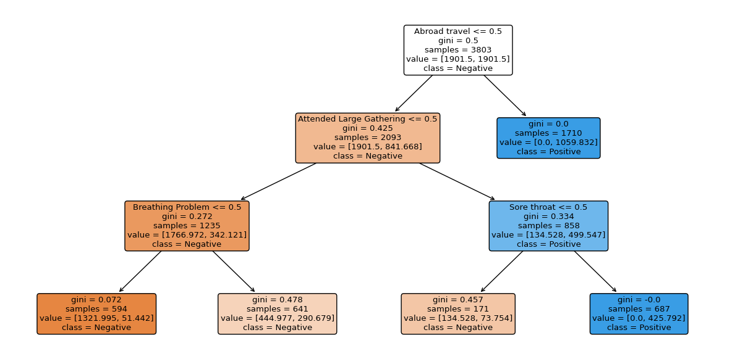
Figure 4: Visualization of the Decision Tree Classifier
K-Means Clustering
Utilizing the K-Means clustering algorithm, we sough to discern patterns within the dataset pertaining to COVID-19 symptoms and behavioral factors. To address the inherent class imbalance in the dataset, oversampling was employed, ensuring equal representation of both COVID-19 positive and negative cases. The clustering process, set to differentiate data into two clusters, yielded results that were subsequently visualized using a 2D scatter plot produced via Principal Component Analysis (PCA).
Evaluation metrics, specifically the silhouette score, were used to assess the quality of the formed clusters. A score of 0.1169 was obtained, suggesting that while some distinction between the clusters exists, there is a degree of overlap, and the samples might be situated close to the boundaries separating the clusters. Though the clusters might not be highly distinct, they do provide a structured view of the data, offering insights into potential groupings based on features at hand.
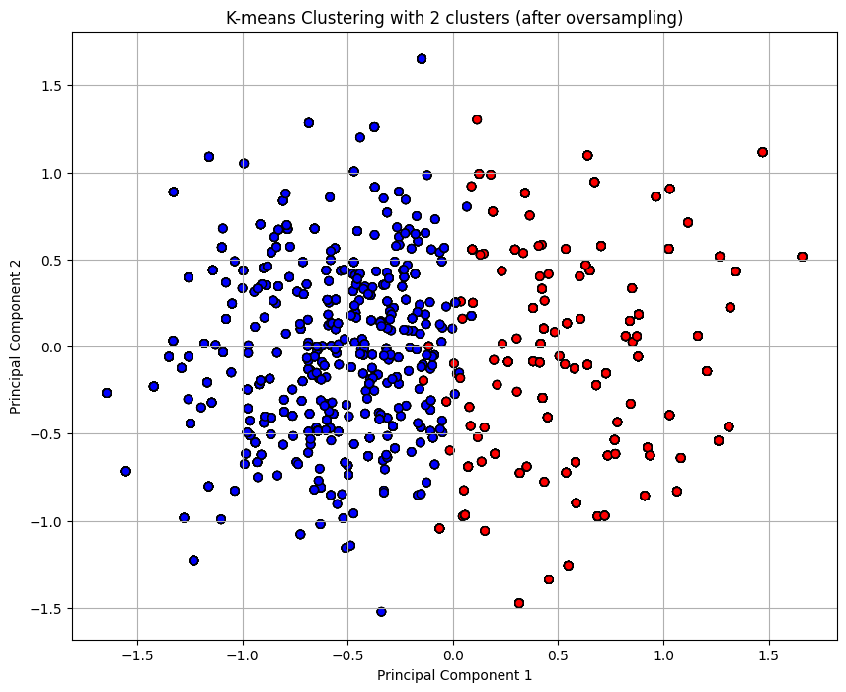
Figure 5: K-Means Clustering Visualization
Hierarchical Agglomerative Clustering (HAC)
The Hierarchical Agglomerative Clustering (HAC) method was employed to uncover hierarchical patterns within the dataset related to COVID-19 indicators. In addressing the inherit class imbalance, oversampling was used, guaranteeing an equal representation of COVID-19 positive and negative cases. The hierarchy of clusters produced was visualized using a dendrogram, which offers a graphical representation of the sequence in which data points and clusters were merged.
To gauge the quality of the clusters formatted, the silhouette score was computed, yielding a value of 0.1102. This score, similar to the one observed with K-means clustering, suggests that the two clusters have some degree of overlap and are not highly distinct. Data points might be positioned close to the decision boundaries of the clusters. However, the hierarchical clustering offers an alternative perspective on potential data groupings and can be instrumental in understanding nested relationships between data points.
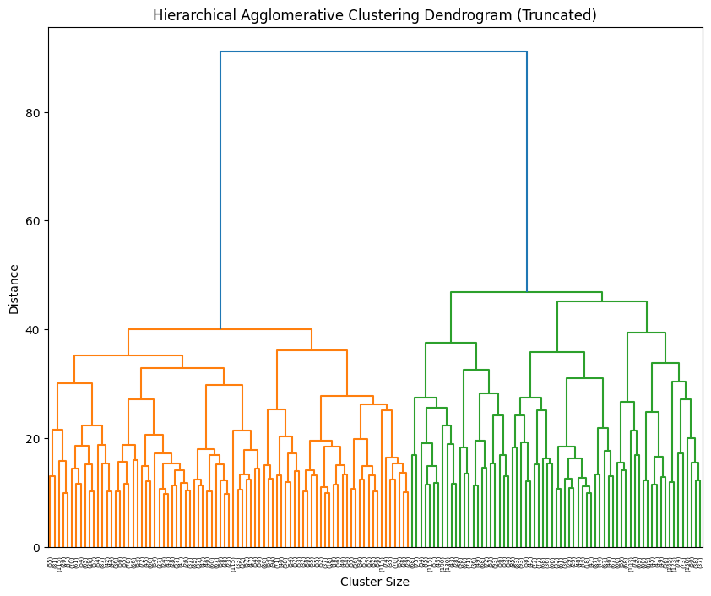
Figure 6: Dendrogram of Hierarchical Agglomerative Clustering
Conclusion
In our endeavors to predict COVID-19 outcomes, three distinct classification algorithms were used: Logistic Regression, Random Forest, and Decision Tree. Each algorithm was meticulously calibrated to address the dataset’s class imbalance. Among these, the Logistic Regression model emerged as the most proficient, with an accuracy of approximately 83.63%. While the Random Forest and Decision Tree classifiers also showcased above average accuracies, their performances were slightly less than the Logistic Regression model. Notably, each classifier presented its set of challenges, especially in correctly identifying the minority class, emphasizing the intricate nature of the dataset.
Transitioning to unsupervised learning approaches, the K-Means and Hierarchical Agglomerative Clustering algorithms were applied after we conducted oversampling techniques to handle the imbalance in our dataset. The two algorithms, gauged using the silhouette scores, revealed that achieving highly distinct clusters still remains a challenge. K-Means, with a silhouette score of 0.1169, just slightly outperformed our Hierarchical Agglomerative Clustering algorithm, suggesting it as a marginally better clustering approach for this dataset. Regarding clustering as a whole for this dataset, it seems our group had better performance when using a classification algorithm.
Throughout this analytical journey, the multifaceted nature of the COVID-19 dataset became increasingly evident. While the Logistic Regression classifier performed the best of all that we tested, K-Means clustering provided a nuanced understanding of potential data groupings. These findings not only underscore the dataset’s inherent complexity but also highlight the transformative potential of data analytics in addressing global health challenges.
References
Tracy A. Prout1, S. Z.-M.-v.-C. (2020). Identifying Predictors of Psychological Distress During COVID-19: A Machine Learning Approach. Retrieved from frontiers: https://www.frontiersin.org/articles/10.3389/fpsyg.2020.586202/full

Zohair Malki, E.-S. A.-D. (2021, April 10). The COVID-19 pandemic: prediction study based on machine learning models. Retrieved from SPRINKER LINK: https://link.springer.com/article/10.1007/s11356-021-13824-7

Rustam, F., Reshi, A. A., Mehmood, A., Ullah, S., On, B.-W., & Aslam, W. (2020, May 25). COVID-19 Future Forecasting Using Supervised Machine Learning Models. Retrieved from IEEE Xplore: https://ieeexplore.ieee.org/abstract/document/9099302

Sumayh S. Aljameel, I. U. (2021). Machine Learning-Based Model to Predict the Disease Severity and Outcome in COVID-19 Patients. Retrieved from Hindawi: https://www.hindawi.com/journals/sp/2021/5587188/

